# Create UDF (User Defined Functions) in Apache Pig and execute it in MapReduce/HDFS mode

**AIM:**

To create UDF (User Defined Functions) in Apache Pig and execute it in MapReduce/HDFS mode.

# PROCEDURE:

1. Install and Configure Apache Pig.
2. Create a python UDF (User Defined Functions).

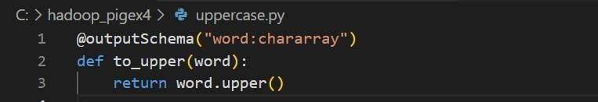

1. Install Jython because Pig will use it to interpret the Python UDFs.
2. Create a Pig script that registers and uses the Python UDF.

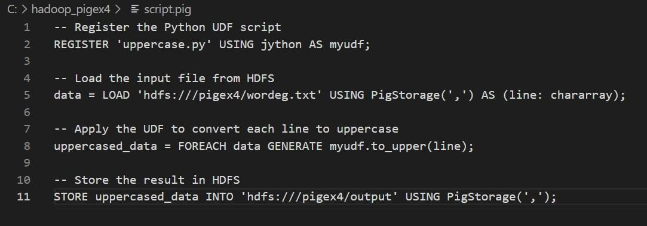

1. Create Directory pigex4 and put the input files inside the created directory.



1. Use the command pig -x mapreduce is used to run Apache Pig scripts in MapReduce mode

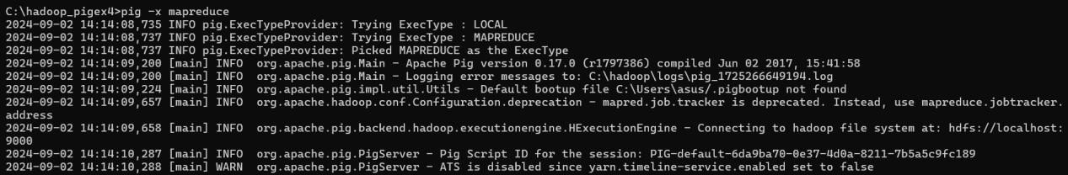

1. After executing the above command you will enter the grunt shell. Here we can execute the script.pig

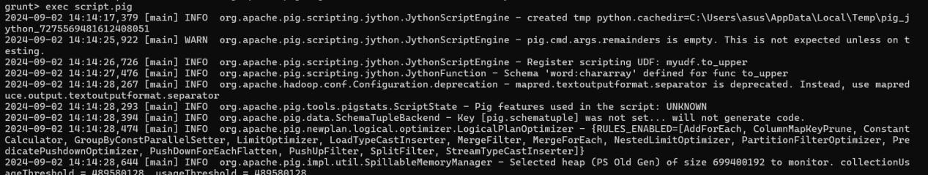

# OUTPUT:

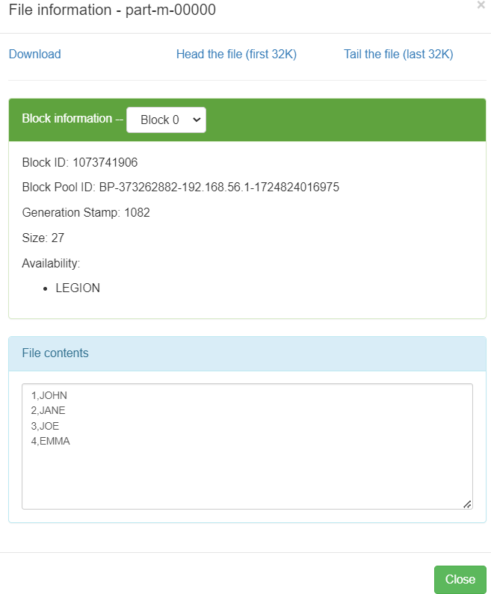

**RESULT:**

Thus, to create a UDF in Apache Pig and execute in MapReduce mode has been executed successfully.